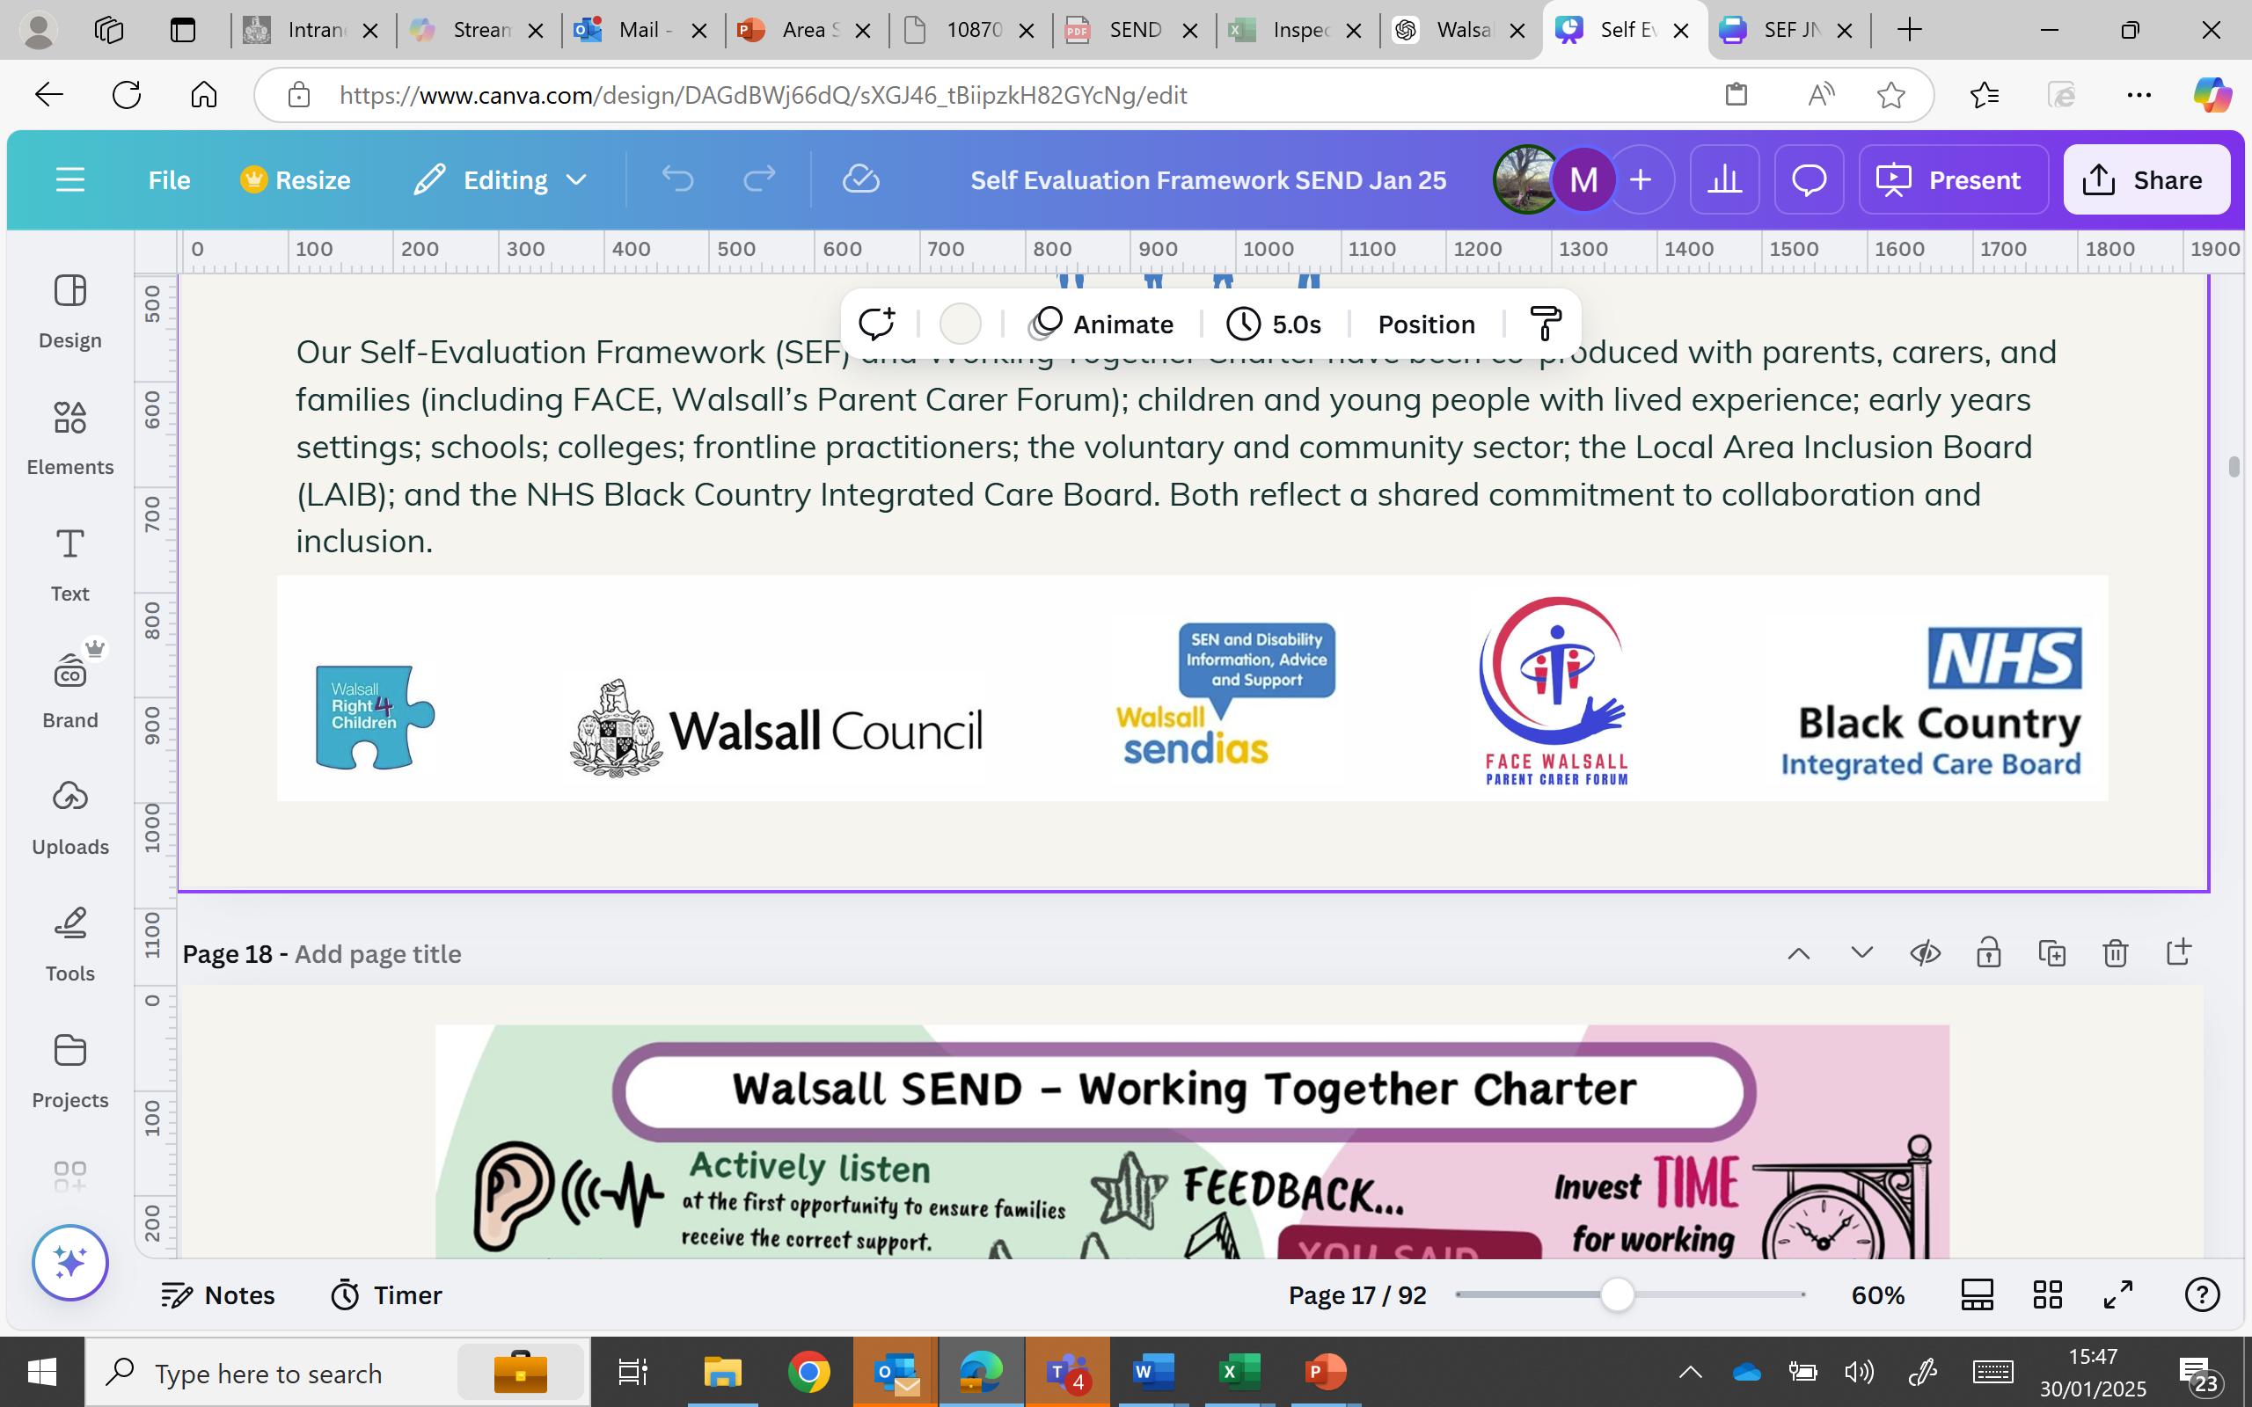

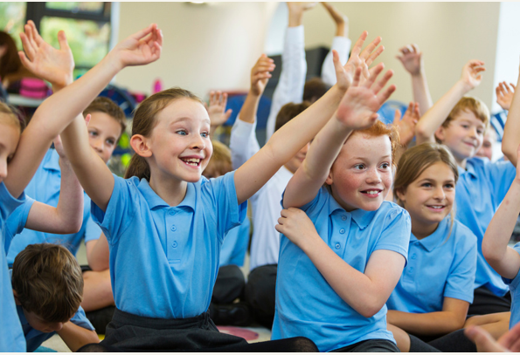


SENCO Guide to the EHC Needs Assessment Pathway

Part 1 EHC Needs Assessment Pathways

Context

Most children and young people with special educational needs or disabilities can have their needs met through inclusive practice in mainstream early years settings, schools, or colleges. All settings have a duty to identify needs early and respond with high-quality, tailored support as part of their ordinarily available provision.

Only a small proportion of children and young people will require an Education, Health and Care (EHC) needs assessment. This is considered when a child or young person’s needs are more complex and where, despite access to ordinarily available provision followed by a robust graduated approach, they continue to require additional and individualised support that cannot reasonably be met from the resources typically available in the setting.

An EHC Plan provides additional, coordinated support across education, health and care, to help secure positive outcomes and prepare for adulthood.

To make a fair and informed decision, the Walsall EHC Team requires information that:

- Captures the views, interests, and aspirations of the child or young person and their family.
- Clearly describes the child or young person’s special educational needs, alongside any relevant health or social care needs.
- Identifies the outcomes being worked towards.
- Specifies the provision needed and how services will work together to deliver it.

The local authority will only consider an EHC needs assessment where there is clear evidence that, despite the setting taking purposeful and sustained action to meet need through SEN Support, the child or young person has not made expected progress or continues to require a significantly higher level of support than can typically be provided through ordinarily available provision.

Graduated Approach
An EHC needs assessment should only be considered where support through SEN Support and the graduated approach has already been carefully planned, delivered and reviewed in partnership with the family. Every mainstream school and early years setting is expected to be inclusive. They must identify and respond to special educational needs early and use their best endeavours to put effective support in place. For most children and young people, this support can be provided through ordinarily available provision and a well-implemented graduated approach, without the need for an EHC Plan.

All schools and settings must follow Chapter 6 of the SEND Code of Practice, which sets out their statutory duties to identify, assess and provide for children with SEN. A helpful summary is available in the Schools Guide to the SEND Code of Practice.
Under the Equality Act 2010, schools must make reasonable adjustments to ensure disabled children are not placed at a substantial disadvantage. This duty is anticipatory, meaning schools must plan ahead and take action without waiting for an EHC Plan to be in place.

Every child and young person is entitled to an education that enables them to:

- Achieve the best possible outcomes.
- Express their views and be heard.
- Prepare effectively for adulthood.

The first step in supporting pupils with SEN is always high-quality, differentiated teaching that addresses barriers to learning. Where additional support is needed, schools must follow the graduated approach — a four-part cycle of:

- Assess – Identify the child’s needs.
- Plan – Agree outcomes and support.
- Do – Deliver the support.
- Review – Evaluate impact and adjust provision.

This cycle should be repeated over time, refining support as more is learned. It forms the foundation of effective SEN Support. Parents and carers must be fully informed and actively involved at every stage. They should understand:

- What support is in place.
- Why it’s being delivered.
- What difference it is making.
- What will happen next.

If a child or young person is still not making expected progress despite targeted, evidence-based support, schools should seek input from relevant external professionals. This must be discussed with and agreed by parents or carers. The SENCO, class teacher and professionals should work together to review progress and plan next steps. This collaborative approach strengthens understanding of need and ensures provision remains purposeful and responsive.

An EHC needs assessment is only appropriate when a setting has taken sustained, purposeful action over time and it is clear that the child or young person’s needs cannot be met without additional, individualised support beyond the setting’s ordinarily available resources.

Applying for a Statutory EHC Needs Assessment

An EHC needs assessment is the first step in the statutory EHC pathway. The local authority’s first decision is whether or not to carry out the assessment. If agreed, the local authority must then decide whether to issue an EHC Plan within 16 weeks of the original request, as part of the 20-week statutory process. It is important to understand that being assessed does not automatically result in a plan being issued.

This process is designed for children and young people with the most complex and long-term needs, where there is clear evidence that, despite access to ordinarily available provision and a well-documented graduated approach, they require significantly more support than can be provided by the setting alone. All requests are assessed using the same legal criteria set out in the SEND Code of Practice. Each case is considered individually, based on whether there is evidence that the child or young person may have special educational needs that require provision which is additional to or different from what is ordinarily available, despite appropriate support having already been provided through SEN Support and the graduated approach.

School Applications

Mainstream schools and early years settings have a legal duty to identify and support pupils with special educational needs through inclusive practice, high-quality teaching, and the graduated approach. In most cases, these needs should be met through ordinarily available provision, without the need for an EHC Plan.

A request for an EHC needs assessment should only be made when the school has taken sustained and purposeful action over time, including external advice where appropriate, and it is clear that the child or young person:

- May have SEN, and
- May require provision that is additional to or different from what is ordinarily available.

When submitting a request, the school must provide clear, well-organised evidence that:

- The graduated approach has been followed and adapted over time.
- Appropriate external professionals have been involved where needed.
- Support has been reviewed, refined, and evaluated.
- The provision required is now beyond what the setting can reasonably provide from existing resources.

Requests must be submitted via the EHC Hub and include:

- A fully completed Appendix B.
- Reviewed SEN Support Plans
- A concise and up to date provision map.
- Reports from relevant professionals (within the last 12–18 months).
- Evidence of parent/carer involvement and pupil voice.

School-led applications are often the most robust, as they can demonstrate:

- A clear golden thread between need, provision, and outcome.
- Reviewed cycles of Assess, Plan, Do, Review (APDR) with meaningful impact statements.
- Evidence that inclusive strategies have been exhausted.
- Provision that clearly exceeds what is ordinarily available.

Applications should avoid relying on diagnosis, attainment levels, or number of support hours alone. The local authority will focus on the impact of need, the provision required, and how this has been adapted over time in response to the child or young person’s progress.

Parent or Young Person Applications

Parents, carers and young people (aged 16 or over) have the right to request an EHC needs assessment at any time. Requests should be submitted via the EHC Hub, which can be accessed through the Walsall Local Offer Welcome to Walsall's SEND Local Offer | Send. Families can also email the SEND team at sen@walsall.gov.uk for support. If a parent or young person is unable to complete the online form, they can contact Walsall SENDIAS for impartial advice and guidance.

While this route is available to families, it should not replace professional responsibility. Where a school or setting has worked through the graduated approach and gathered appropriate evidence, it is expected that the setting will lead the request for assessment.
These applications are usually stronger, as they are informed by clear, structured information about needs, provision and outcomes over time. If a request is submitted by a parent or young person, the school will be asked to contribute evidence through the completion of App B within 10 working days. This includes context, provision already in place, and progress made. If the school agrees that an assessment is necessary, the local authority will ask why a school-led request was not made in the first instance. Where there is disagreement between the family and the school, the local authority will review the evidence submitted by both parties as part of the decision-making process.

What to expect and when, during the Statutory Assessment

Stage 1: Request for Assessment (Weeks 0–6)

- A request for an Education, Health and Care (EHC) needs assessment can be made by a parent, carer, young person (aged 16+) or by an education setting.
- The Local Authority (LA) considers the request and gathers initial information from the family and setting.
- By week 6, the LA must inform you whether an EHC needs assessment will go ahead.
- If the request is refused, you will be given the reasons and informed of your right to mediation and appeal

Stage 2: Assessment (Weeks 6–16)

- If the assessment is agreed, advice is requested from education, health and social care professionals, as well as the child/young person and their family.
- This advice must be provided within 6 weeks.
- The LA considers the evidence and decides whether an EHCP is needed.
- By week 16, you will receive either:

  - a decision to issue a draft EHCP, or
  - a decision not to issue a plan, with reasons provided and information about your right to mediation and appeal.

Stage 3: Draft Plan (Weeks 16–18)

- If the LA agrees to issue an EHCP, you will be sent a draft plan.
- Families and young people have 15 calendar days to:

  - comment on the draft,
  - suggest amendments, and
  - express a preference for an education setting.

Stage 4: Final Plan (Weeks 18–20)

- The LA consults with your preferred school or setting, who must respond within 15 days.
- By week 20, the LA issues the final EHCP, naming the agreed education setting and outlining the support to be provided.
- The final plan is shared with parents/young people and professionals. It also explains your right to appeal if you are unhappy with any part of it.

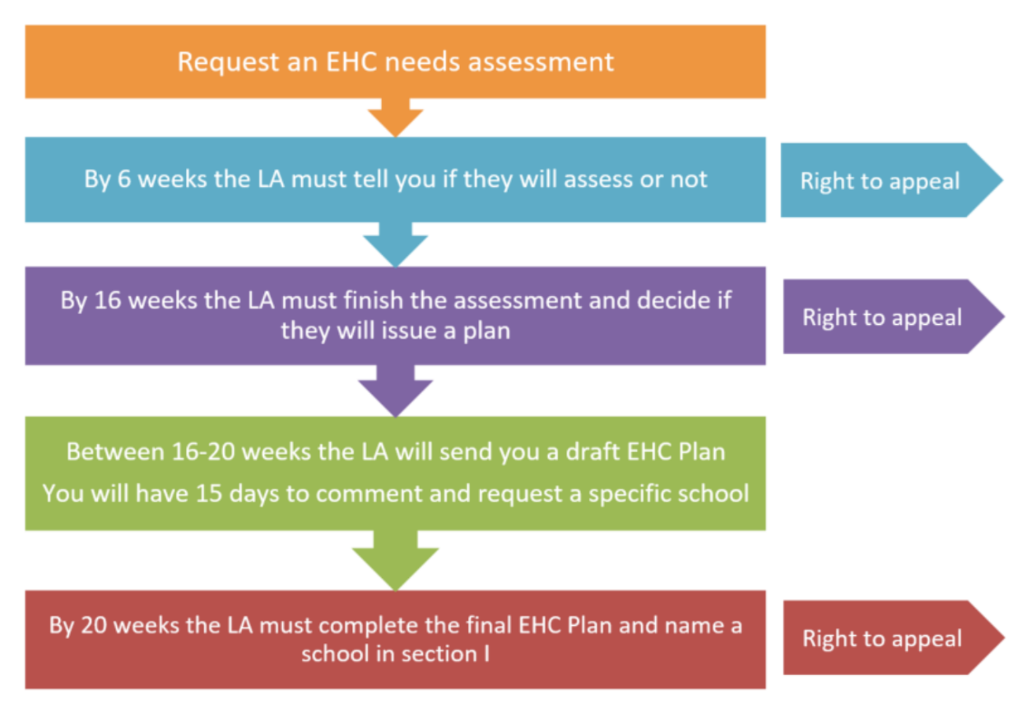
Statutory EHC Needs Assessment
Schools Information App B

From September 2023 all requests for an EHC Needs Assessment must be made on this form and uploaded to the HUB.
Please complete sections 1-5 on the HUB & upload any further supporting documentation.

Guidance

Children or young people should only be referred for statutory assessment following a graduated approach of intervention, as advised in the SEND Code of Practice 2015.

The form below outlines information that must be completed. Partially completed forms will be returned.
Additional reports must be word processed and attached as an electronic copy.
This referral will only be considered if accompanied by the appropriate evidence as set out in Appendix A: Checklist

PARENTAL AGREEMENT TO STATUTORY ASSESSMENT

I/We agree/do not agree* to a formal statutory assessment of my/our child’s special educational needs and to the involvement, assessment and information sharing from Social Care, Health, Education Psychology, and other relevant professionals for such an assessment.

*Please delete as appropriate and sign below.

Name…………………………………………….  Signature……………………………………….. | Date…………………………………………….

Contact Details

CYP First Names |  |  |  |  | CYP Surname
Home Address |  |  |  |  | Date of Birth
 |  |  |  |  | Contact Number
 |  |  |  |  | Email
Educational Setting |  |  |  | Year Group |  |  |  | SENCO Name
Gender | First Language |  | Ethnicity |  |  | NHS Number |  |  | CAF/EHA/CIN/CP
GP Contact Details

Persons with Parental Responsibility |  | Relationship |  |  |  |  | Contact Details (if different)
Best person (family member) to contact |  | Name and method of contact
LAC Yes ☐ No ☐ |  | Social Worker Name and Contact Details
If YES, which authority is responsible for this child or young person?
Details of any interpretation/access support needed for the family…

Relevant professionals involved or professionals who can help with this assessment.

 | Name | Role | Level of involvement | How long have they known the CYP | Do you have a report?
Education
Healthcare
Social Care
Other

Information and advice from the educational setting

Summary of child or young person’s SEND:
What is the impact on education? What are the barriers to learning and main difficulties identified?
Summarise the child or young person’s strengths, interests, and aspirations:
Context and Background

Include any relevant home/community information:

Description of the child or young person’s current attainment and rates of progress.
Please explain any levels so we can gain an understanding of progress:
What outcomes have been focused on? | These should also be outlined on an SEN support plan
What additional staffing support has been given to the child or young person? Please link this information to outcomes. What has the impact of this support been?
Record any additional interventions or actions taken during increasing cycles of APDR. These should also be detailed on a Provision Map / SEN Support Plan and linked to outcomes.
Summarise where more advice is required:

This can be additional assessment, advice, guidance, resources, environmental changes.
What will an EHC Plan give the child or young person? What will top up funding allow in addition to existing support?
Previous educational settings with dates of transfer or change of Key Stage:
Current attendance:
Reasons for non-attendance (below 85%):
Number of fixed term exclusions (days per year) with reasons for exclusion.

Please do not send in daily logs or diaries.

Individual Needs Analysis

 | Strengths | Barriers | Outcomes | Provision | Strategies that would help (adapted QFT)
Communication and Interaction
Cognition and Learning
Social, Emotional and Mental Health
Sensory and/or Physical

Preparation for Adulthood (Year 9 Onwards)

Higher Education and / or Employment | Strengths:
Higher Education and / or Employment | Needs:
Independent Living | Strengths:
Independent Living | Needs:
Participation in Society | Strengths:
Participation in Society | Needs:
Being as healthy as possible in adult life | Strengths:
Being as healthy as possible in adult life | Needs:

Additional Notes and Important Information
Dates of SEN Support Review Meetings
Appendix A: Check List

All the information below MUST be provided:

Signed Parent/Carer Agreement.
**the request will not be processed without this**

GP Name and Address.
**the request will not be processed without this**

A One Page Profile.

A Costed Provision Map (or Costed Walsall SEN Support Plan).

Evidence of a Graduated Approach for a minimum of 2 APDR cycles (SEN Support Plan / Individual Education Plan).

Attainment Records (review of progress, over the last 12 months).

Evidence of professional support e.g. outreach, specialist teacher, early years SEN, virtual school or educational psychology involvement.

Evidence of any Social Care involvement. Evidence the school/setting has considered whether an Early Help Assessment is required as part of the EHCNA. A copy of the referral and minutes from any multi-agency meetings MUST be attached. Please provide information about current social care status.

Evidence of the universal health offer being explored and referrals to appropriate professionals as appropriate (e.g. Speech and Language Therapy, Paediatrics, Occupational Therapy). You MUST include any reports or information.

**An EHCNA request does not substitute a referral to health services and referrals must be in place prior to the EHCNA for advice to be received from health services**

Connexions Advice (for young people Year 9 and above).

Evidence from Alternative Providers involved (where applicable).

Part 2 EHC Annual Review Pathway

EHC Plan Annual Review Guidance for SENCO’s

September 2026

Preparing for the EHC Plan Annual Review Meeting

Preparation for the Annual Review meeting can start at any time that fits in with the school calendar. The LA SEN Team will send a list to the setting each term of the children or young people with EHC plans who are due a review. It will be your responsibility to arrange the meetings in a timely manner.

Please note that the annual review process for a Phase Transfer (moving from one educational stage up to the next) should allow plenty of time for planning and consideration of new provisions.

All Phase Transfer Annual Review meetings should take place in the Autumn Term.

Year Group | Timeframe for Phase Transfer Annual Reviews
Nursery/Pre-school moving up to Reception. | Nursery/Pre-school Annual Review 2 meeting to be held in the first half of the Autumn Term.  All Annual Review Paperwork to be submitted to the SEN Team by 23rd October 2026.
Year 2 moving into Year 3. | Year 2 Annual Review meeting to be held in the first half of the Autumn Term. All Annual Review Paperwork to be submitted to the SEN Team by 23rd October 2026.  This early review requirement applies only to pupils attending infant schools, to support transition to junior school. For pupils attending primary or all-through schools, Annual Reviews should take place at their usual point in the review cycle. Any amendments identified through the review will still be processed by the Local Authority in the normal way.
Year 6 moving into Year 7. | Year 6 Annual Review meeting to be held in the first half of the Autumn Term.  All Annual Review Paperwork to be submitted to the SEN Team by 23rd October 2026.
Year 11 moving to Post 16. | Year 11 Annual Review meeting to be held in the Autumn Term.  All Annual Review Paperwork to be submitted to the SEN Team by 18th  November 2026.
Year 13 moving to Post 19. | Year 13 Annual Review meeting to be held in the Autumn Term.  All Annual Review Paperwork to be submitted to the SEN Team by 27th  November 2026.

If you are recommending an increase or change to a child or young person's current provision (or a specialised placement) as part of the Annual Review process, you must provide additional detailed evidence to demonstrate why these changes are required.

We begin our discussions & consultations for specialised placements from October.
Please ensure specialised placement requests are submitted to the EHC Team by the End of September 2025.
Before the Annual Review Meeting
(Advised 4-6 weeks before)

Checklist
Send meeting invitations to family and relevant professionals (a minimum of 2 weeks before)
Notify LA SEN Team of meeting date (a minimum of 2 weeks before)
Request a copy of any reports completed by professionals within the last 12 months (be aware that this process can take several weeks)
Request written contributions from Parent/Carers
Complete Child or Young Person’s Views
Complete Preparing for Adulthood Form (for all young people from Year 9)
Complete The SENCO Report (share with all attendees and the LA SEN Team a minimum of 2 weeks before)

The Annual Review Meeting

The Annual Review meeting must enable full involvement of the parent/carer, child or young person and consider their views, wishes and feelings especially when making decisions. It is important to check all sections of the EHCP not just the educational targets and provision. This provides an opportunity for parents/carers and CYP to request changes and updates. It may also be that what you expected to happen, based on your understanding/interpretation of various elements of the EHCP has not been delivered exactly as you had anticipated.

The Annual Review meeting must focus on progress made towards achieving outcomes and establish whether the current outcomes remain appropriate. If it is required, new outcomes should be agreed. You must review the special educational provision, how it is delivered and ensure it is still appropriate to enable good progress. It is important to review any health and social care provision. The family, child or young person’s aspirations should be central and a discussion should focus on whether these have changed. You must check if the family, child or young person would like to request a Personal Budget.

The meeting should focus on future planning and not just on how things have gone in the past year. Person Centred Planning Practice recommends that the voice of the child should be considered first in the meeting. Other aspects of the meeting can then be discussed within the context of the child’s wishes. All present at the meeting, especially the child, young person and parents/carers should be given the opportunity to express their views about all aspects of the review.

All proposed amendments should be completed on a word version EHC plan (typed, using strikethrough & coloured text where applicable so this can be read and interpreted easily by our SEN Caseworkers).
Following the Annual Review Meeting

No later than 2 weeks after the meeting please send the following completed documentation to the LA SEN Team

Checklist
EHC Annual Review Report
All proposed amendments on a word version EHC plan
A copy of the child or young person’s most recent attainment data
A copy of the child or young person’s attendance data
Any reports completed by professionals within the last 12 months
Parent/Carer Views
Child or Young Person’s Views
Preparing for Adulthood Form (for all young people from Year 9)
Walsall SEN Support Plan / Provision Map to support any recommendation for an increase/change to current provision.

Early or Interim Annual Reviews
An early or interim Annual Review may be appropriate where the education, health or social care provision specified in the EHCP is no longer meeting the child or young person's needs. This may include, for example, where a child or young person has been excluded from school or is at risk of exclusion.
As these reviews fall outside the normal Annual Review cycle, schools and settings must contact the LA SEN Team before arranging the review. The Local Authority will consider the circumstances and confirm whether an early review is appropriate.
Where an early review is agreed, the statutory Annual Review process must be followed, and all documentation and supporting evidence must be submitted in line with this guidance.

Please email all Annual Review documentation to:
SEN@walsall.gov.uk
SENCO Report
The SENCO report should be completed before the Annual Review. This report gives the family an update of provision and outcomes and supports better preparation for the meeting. You may want to change the format or look of this form. We would ask that the current headings remain the same although you can add anything to make it more appropriate to your individual setting.

CYP Name: | Year group:
Setting: | Name of SENCO:
Summary of identified Special Educational Needs
Summary of provision that is in place in school (attach current SEN Support Plan/Provision Map)
Key support strategies that have helped
Summary of progress that has been made this year
- What progress has been made towards the EHCP outcomes?
- What evidence demonstrates this progress?
- Are the current outcomes still appropriate?
- What changes, if any, do you recommend to the outcomes or provision?
Things that are working well, including special recognitions and achievements
Things that could be better
Friendships, relationships and social development
What we are planning to do now, next and later

SENCO Signature: | Date:

The Parents/Carer form should be completed before the review meeting and circulated with any additional information at least 2 weeks before. We advise it is completed 4-6 weeks before to allow for better preparation. You can add additional headings or collect this information in any way which supports the family.

Parent/Carer Views

CYP Name: | Parent/Carer Name:
Setting: | Name of SENCO:
Achievements and Strengths
What are your child’s strengths? What do you think is working well at home and at school? What achievements has your child been most proud of during the past 12 months?
Concerns and Worries
Do you have any current concerns? What do you think is not working well? What could be better?
Friendships and Relationships
Tell us about your child’s relationship with their peers and the adults who support them…
Learning and Educational Progress
Is your child making progress in their learning? How successful has the EHC plan been this year? Are the EHC outcomes appropriate? Has the provision in place helped?
Health and Wellbeing
Has there been any changes to your child’s health, wellbeing or special educational needs over the past 12 months? Are there any unmet health or social needs that should be supported?
Aspirations and Goals
What are your future aspirations for your child? What would you like to see happen in the next 12 months?
Important information to know
Anything else you would like to tell us?

Child or Young Person’s Views

The Child or Young Person’s Views can be submitted in whatever format best suits the individual. You may want to consider alternatives to writing such as mood boards, paintings or photographs. We can accept power point presentations, videos or any other media platform. This is a fully open section of the Annual Review process. Views should be gathered before the review meeting and circulated with any additional information at least 2 weeks before. However, we advise they are completed at least 4-6 weeks before the meeting to allow for better preparation.

The following conversation starters may be useful:

What things have you enjoyed doing most this year?
What activities did you do well in?
Who or what helps you in school?
What has gone well for you this year?
What are you pleased about?
What has made a difference to your family?
What is your proudest moment?
What are your aspirations?
What is important to you?
What would you like to do more of?
Is there anything you are concerned about?
What has been a challenge you this year?
What do you feel needs to change?
What would you like to do outside of school?
What would you like to do in the future?
What job would you like?
Where would you like to live?
What might you need help with to do this?
What have you not enjoyed doing this year?
What have you found hard this year?
What could make things easier?
What do you currently do with your friends and what would you like to do?
Is there anything you are worried about?
What do you do outside of school and what would you like to do? Do you need help with this?
Are you happy with your friends? Do you find making friends difficult? Would you like more help with this?

Preparing for Adulthood

Preparing for Adulthood (PfA) is not a single transition point. It’s a continuous journey that should begin early and unfold over time, through relationships, everyday experiences, choices and growing confidence. Every young person’s path will be different, and that’s exactly as it should be.

In line with the SEND Code of Practice (2015, Section 8.9), all Annual Reviews from Year 9 must include a focus on preparing the young person for adulthood. Planning must be centred on the young person’s aspirations and abilities. What they want to be able to do when they leave further education and how they can be supported.

Young people should have the information they need to move onto the next stage of their lives. Some young people will move to employment or higher education, or to on-going health/adult services including adult learning opportunities.

Schools and colleges should raise the career aspirations of their students with SEN and broaden their employment horizons. They should ensure that students are provided with independent careers guidance and use taster opportunities, work experience, mentoring, role models and inspiring speakers to assist young people to make informed decisions.

Independent Travel Training is available for Year 9 pupils. If a CYP would like support with independent travel training, please contact the SEN Team. When doing so please identify any factors that may support engagement, along with any barriers that could impact the child or young person's ability to access or participate in the programme.

The resource below outlines examples of aspirations, activities and provision that can support progress towards Preparing for Adulthood (PfA) outcomes across different ages and stages of development. It is not an exhaustive list but is intended as a helpful starting point for planning and discussion.

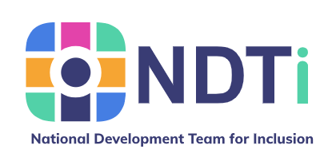
PfA-Outcomes-Framework.pdf

Preparing for Adulthood: All Tools & Resources - NDTi

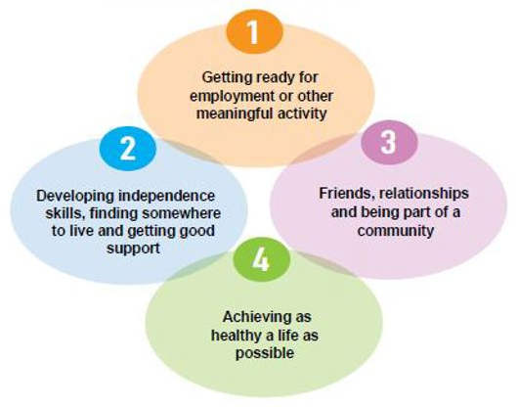
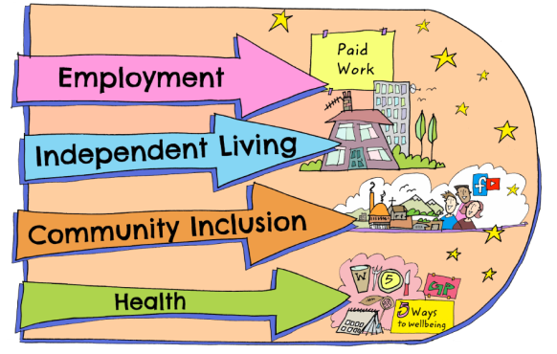

Preparing for Adulthood
The Preparing for Adulthood form should be completed before the review meeting by young people in Year 9 and above. We advise it is completed 4-6 weeks before to allow for better preparation. You can add additional headings or collect this information in any way which supports the young person.

CYP Name: | Year Group:
Setting: | Name of SENCO:
Things I like to do

In my spare time: | At school or college:
Important people in my life
Things that are going well | Things I would like to change
What is important for my future?
My goals and aspirations
Education and Employment:
What am I aiming for in terms of college or training? Do I have an idea about which course or setting I would like to attend? What kind of work or career might suit me? What do I need to do to achieve this?

Independent Living:
What am I thinking about where I would like to live as an adult? What help might I need to achieve this? What can I do for myself at the moment and what skills do I still need to learn?

Maintaining Good health:
What am I hoping for in terms of my health? (arranging/ attending appointments, medication, diet and exercise, safe relationships etc.)
Friends, Relationships and Engaging in the Community:
What kind of life would I like as an adult with my friends? How can I connect with my local community? What help and support may I need to understand and build safe relationships?

How best to support me
The best way to support me with communication, learning, making my own decisions and becoming independent.

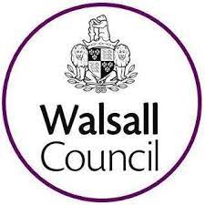
EHC Annual Review Report

Family Name |  |  |  |  | First Names
Home Address |  |  |  |  | Date of Birth
 |  |  |  |  | Telephone
 |  |  |  |  | Email
Educational Setting |  |  |  | Year Group |  | SENCO
Gender | First Language |  |  | Ethnicity |  | NHS Number
GP Contact Details |  |  |  |  |  | CAF / EHA /CIN
Persons with Parental Responsibility |  |  | Relationship |  |  | Contact Details if different
Best Person to Contact family member |  |  | Name and Method of Contact
LAC Yes ☐ No ☐ |  |  | Social Worker name and contact
If YES, which authority is responsible for this child / young person? /Contact details
Details of any interpretation/access support needed for the family.

Date of Last review meeting: |  |  |  |  |  |  | Date of current review meeting:
Persons who attended the review meeting
Name |  | Designation/Role |  |  |  |  |  | Invited
In line with the SEND Code of Practice 2015 and the child’s / young person’s progress, does the Education, Health and Care Plan need to be:

Maintained  There are no changes required to the plan at this time. It is not anticipated that every review will require amendments to be made to the EHC plan. |  | Ceased  The identified outcomes have been met and the child/young person’s needs can be met from the SEND support arrangements within the setting. |  |  |  |  | Amended  The plan requires some changes. (Any changes should have been proposed and communicated a minimum of 2 weeks before meeting).
Was everyone at the meeting in agreement? Please list any areas which were not agreed during the meeting.
Please list any actions or tasks agreed during the meeting. Only assign tasks with agreement of person responsible.
Task or action required |  | Person responsible for completing action |  |  |  |  | Date action will be completed by
Preparing for Transfer between Phases of Education
Transition Year Group |  | Preferred Type of Setting |  |  |  |  | Parent/Carer Comments
EYFS to KS1
KS1 to KS2 (If applicable due to separate settings)
To be compiled for Yr. 1 pupils
KS2 to KS3
To be compiled for Yr. 4 pupils
Post 16 education, employment or training.
To be compiled for Yr. 10 pupils
*Children and young people with special educational needs and disabilities needs may be eligible for help with transport to the school or college which is the most appropriate for their needs. Where an alternative school is parental preference and may not be the most local school to the home address, transport may not be provided. Please refer to Home to school transport | Walsall Council for the most up to date transport policy and information.

Details of the person completing this form
Name |  |  |  |  |  |  | Role
Name of setting
Email
Signature |  |  |  |  |  |  | Date

What happens next?

Following an Annual Review meeting where changes to an EHC plan are proposed, the Local Authority will consider the recommendations and review the submitted documentation. Within 4 weeks of the Annual Review meeting, the Local Authority will notify parents/carers (or the young person) of its decision to maintain, amend, or cease the EHC plan. If the decision is to amend the plan, the Local Authority will issue an amendment notice, followed by a draft amended EHC plan, typically issued within 8 weeks of the Annual Review meeting. Parents/carers (or the young person) will have 15 days to make comments or request further changes. The Local Authority must then issue the final amended EHC plan within 8 weeks of issuing the draft.

Ceasing a plan

For plans that are proposed to cease (as the support is no longer required by the child or young person and not because of relocation), the school will need to submit the EHC Annual Review Report no later than 2 weeks after the meeting. This will then be processed by the LA SEN Team and the proposal to cease looked at by a centrally based decision-making group. If proposal to cease is agreed, the Local Authority will issue a notice to parent/carer or young person in line with Code of Practice.

Please email all Annual Review documentation to:
SEN@walsall.gov.uk

